Find Popular Node of Graph

using Centrality

**EECS - 221**



Name - Snehal Srinivas Gandham

ID-79007757

Table of Contents

Table of Figures 3

1. CENTRALITY 4

1.1 Different Types of Centralities: 4

1.1.1 Degree Centrality: 4

1.1.2 Closeness Centrality: 5

1.1.3 Betweeness Centrality: 5

1.1.4 Katz Centrality[5] 6

1.2 Applications of Centrality in General: 7

2. ALGORITHM 8

3. UI 10

4. RESULTS OF TEST CASES 11

5. SUMMARY AND DISCUSSION 17

REFERNCES 20

APENDIX 21

# Table of Figures

|  |  |
| --- | --- |
| Figure No | Description |
| 1 | Home page of the project |
| 2 | Betweenness Centrality for 6 nodes |
| 3 | Betweenness Centrality for 880 nodes |
| 4 | Degree Centrality for 6 nodes |
| 5 | Degree Centrality for 880 nodes |
| 6 | Closeness Centrality for 6 nodes |
| 7 | Closeness Centrality for 880 nodes |
| 8 | Katz Centrality for 6 nodes |
| 9 | Closeness Centrality for 880 nodes |
| 10 | Final Centrality after Betweenness Centrality is Calculated |
| 11 | Final Centrality after Degree Centrality is Calculated |
| 12 | Final Centrality after Closeness Centrality is Calculated |
| 13 | Final Centrality after Katz Centrality is Calculated |

# CENTRALITY

The most important vertices of the graph are identified by centrality scores. There are many ways of calculating centrality. Each vertex is assigned a value based on the type of centrality used. Various types of centralities are as follows:

1. Betwenness Centrality
2. Degree Centrality
3. Closeness Centrality
4. Katz Centrality
5. Graph Centrality
6. Stress Centrality

## Different Types of Centralities:

### Degree Centrality:

This centrality defines the number of edges incident upon a vertex. Indegree and Outdegree can be used. Number of edges pointing towards a node is called Indegree and number of edges pointing to other nodes is called outdegree.

Consider a graph G (V, E), with V as the vertices and E as the edges. The centrality can be calculated as

CD = deg(V)

O(V2) time is taken for the calculation of degree centrality in a dense adjacency matrix whereas O(E) time is taken in a sparse matrix.

Applications:

1. The node which has highest risk of catching the disease can be found.
2. Popularity can be gauged using Indegree whereas gregariousness can be gauged using Outdegree.

### Closeness Centrality:

This centrality is defined as reciprocal of sum of length of shortest paths between the node to other nodes. Bavelas defined the centrality as

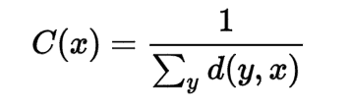

Websites with outgoing link can have high closeness centrality whereas it might be low with incoming links.

### Betweeness Centrality:

This is defined by the number of shortest paths that pass through the vertex.

Betweenness Centrality is given by:

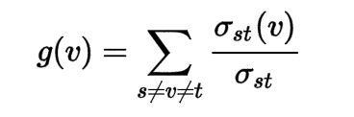

where,

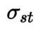 {\displaystyle \sigma _{st}}is the total number of shortest paths from node {\displaystyle s}s to node t

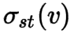  is the number of paths that pass through v

So, the shortest paths have to be found and calculated based on the distance.  [Floyd–Warshall algorithm](https://en.wikipedia.org/wiki/Floyd%E2%80%93Warshall_algorithm) will take O(V3) time for finding the shortest paths. On a sparse graph, Johnson and Brandes Algorithm will take O (V2 log V + VE). For unweighted graphs, Brandes Algorithm will take O(VE) time for calculating the centrality.

{\displaystyle t}t

tt t

Applications:

1. In a telephone network, a node with high Betweenness Centrality will have higher importance as more information will pass through it.

### Katz Centrality[5]

This centrality computes the relative influence of node on the network. Number of neighbors as well as the number of nodes which can connect to the node through the neighbors are taken into consideration. Attenuation factor, Alpha is used to attenuate the increasing distance. Power of edge distances are used for the calculation.

Applications:

* 1. Can be used to find the firing rate of neurons. [7]
  2. Can be used to find the influence of actors in a Social Network.
  3. Can be used to find the centrality in Citation networks or World Wide Web.

## Applications of Centrality in General:

1. In a social network, the most important people can be identified.
2. Find who can be the gossipmonger among the list of friends.
3. The famous celebrity among a list of celebrities can be found.
4. The source cell responsible for the spread of the disease can be found.
5. The substation which can face the most load in a telephone network can be found.
6. Patterns of Social Relationships can be found.

# ALGORITHM

* Brandes Algorithm[6] has been considered instead of Floyd-Warshall Algorithm as the complexity for finding the shortest distance is less. The algorithm has been implemented from the algorithm given in the link (<http://algo.uni-konstanz.de/publications/b-fabc-01.pdf)>

CB[v] ← 0, v ∈ V ;

for s ∈ V

do S ← empty stack;

P[w] ← empty list,

w ∈ V ;

σ[t] ← 0, t ∈ V ;

σ[s] ← 1;

d[t] ← −1, t ∈ V ;

d[s] ← 0;

Q ← empty queue;

enqueue s → Q;

while Q not empty do

dequeue v ← Q;

push v → S;

foreach neighbor w of v do

/ w found for the first time?

if d[w] < 0 then enqueue w → Q;

d[w] ← d[v] + 1;

end

// shortest path to w via v?

if d[w] = d[v] + 1 then

σ[w] ← σ[w] + σ[v];

append v → P[w];

end

end

end

δ[v] ← 0, v ∈ V ;

// S returns vertices in order of non-increasing distance from s

while S not empty do

pop w ← S;

for v ∈ P[w] do δ[v] ← δ[v] + σ[v] σ[w] · (1 + δ[w]);

if w != s then CB[w] ← CB[w] + δ[w];

end

shortest_path[src] = dist;

end

The Degree centrality has been calculated by

for s ∈ V

deg[s] = adj[s].size()

Closeness and Katz Centrality has been calculated by

for i ∈ V

for j ∈ V

close_cent[i] += shortest_path[i][j];

katz[i] += deg[j]*power(alpha,shortest_path[i][j]);

end

close_cent[i] = 1/cose_cent[i];

end

# UI

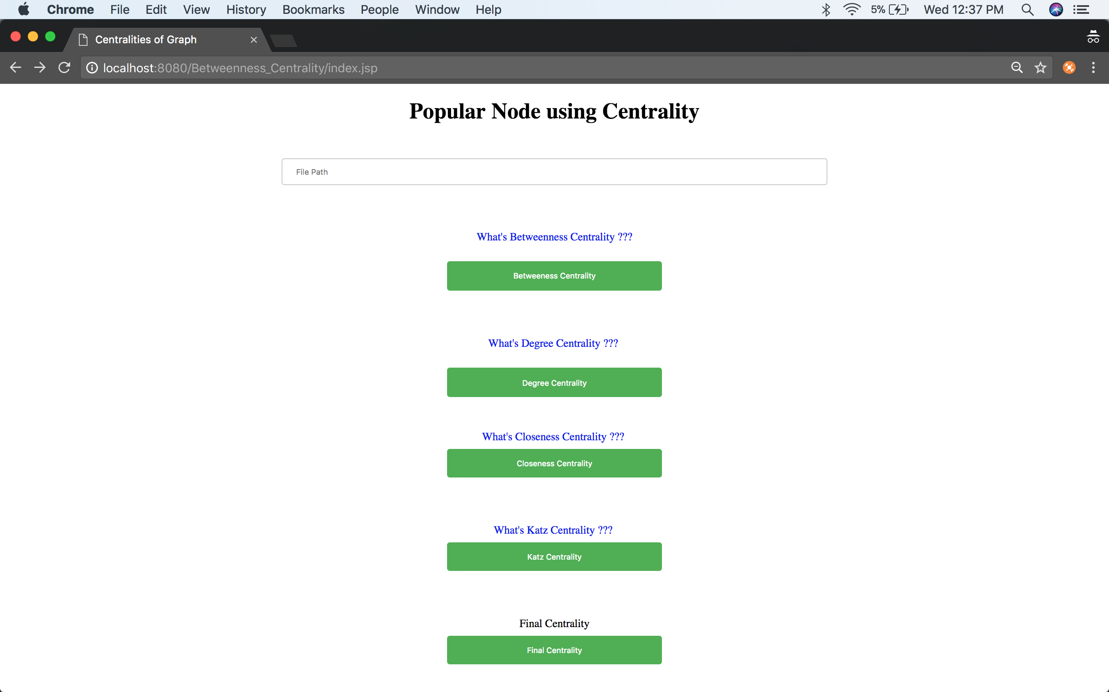

Fig 1

* The path of the file has to be entered.
* Each of the centrality buttons can be clicked to check the centralities
* Also, the final centrality can be seen by click “Final Centrality button”

# RESULTS OF TEST CASES

Home page of the project using which the path of the file can be given and the following centralities can be calculated.

1. Between Centrality
2. Degree Centrality
3. Closeness Centrality
4. Katz Centrality

The test files can be found at :

<https://github.com/ssgandham/Calculate-Betweeness-Centrality-using-Brandes-Algorithm-Closeness-Centrality-and-Degree-Centrality/tree/master/TEST%20CASES>

Betweenness Centrality:

* For 6 nodes and 7 edges

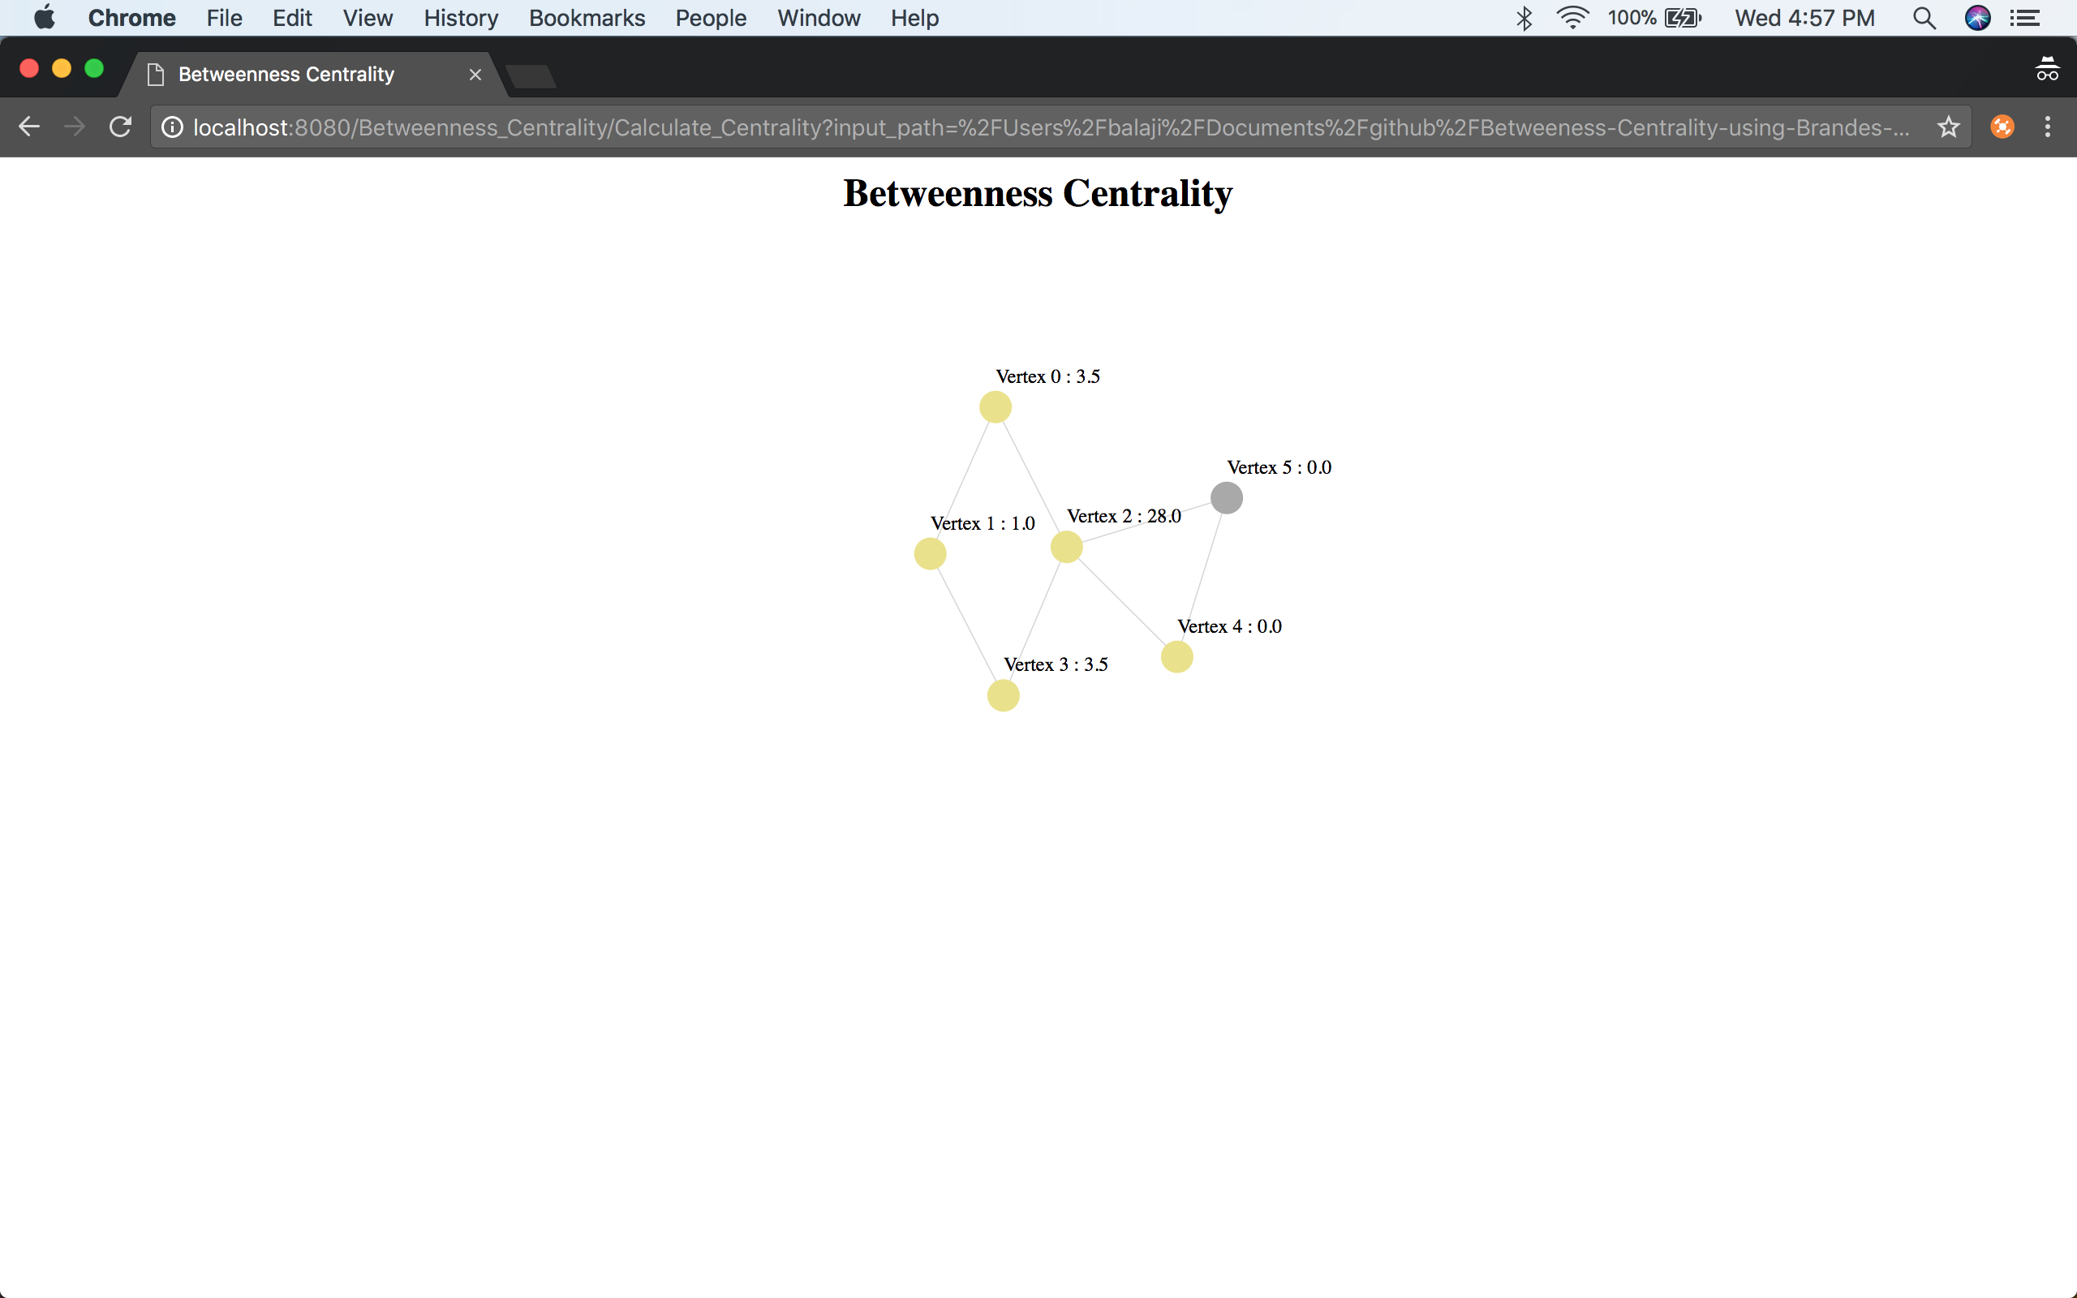

Fig-2

* For 880 nodes and 1000 edges

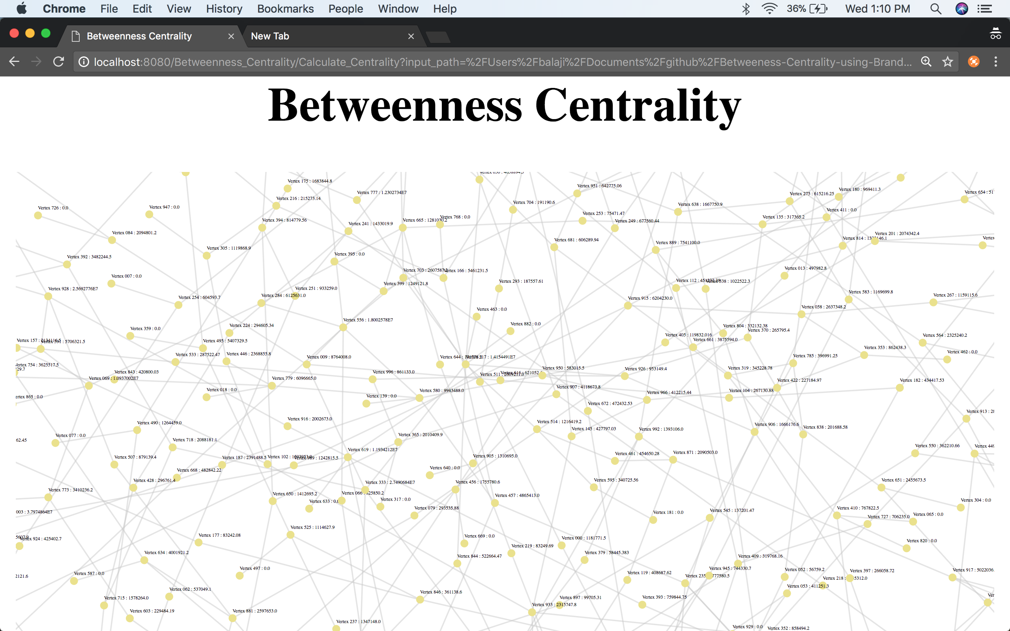

Fig-3

Degree Centrality

* For 6 nodes and 7 edges

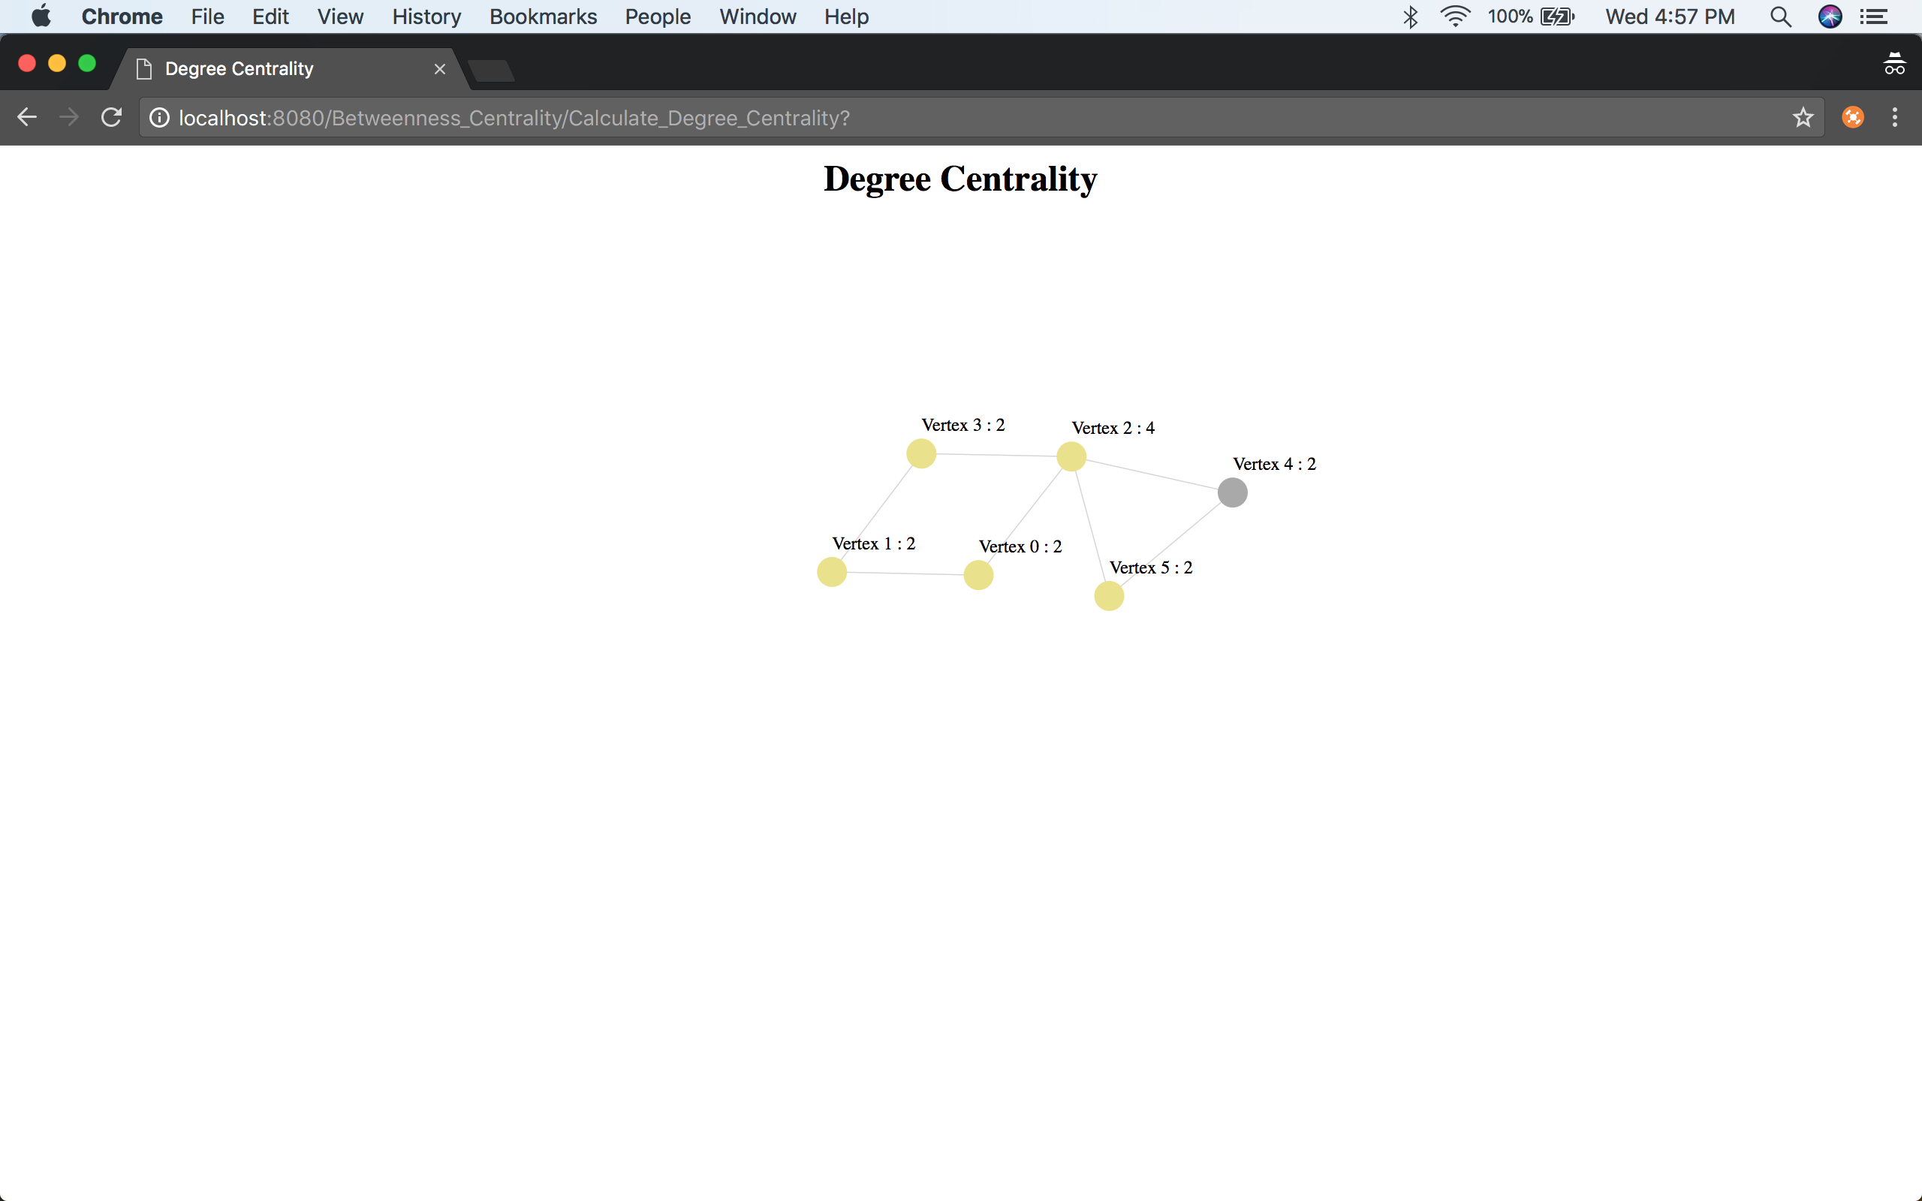

Fig-4

* For 880 nodes and 1000 edges

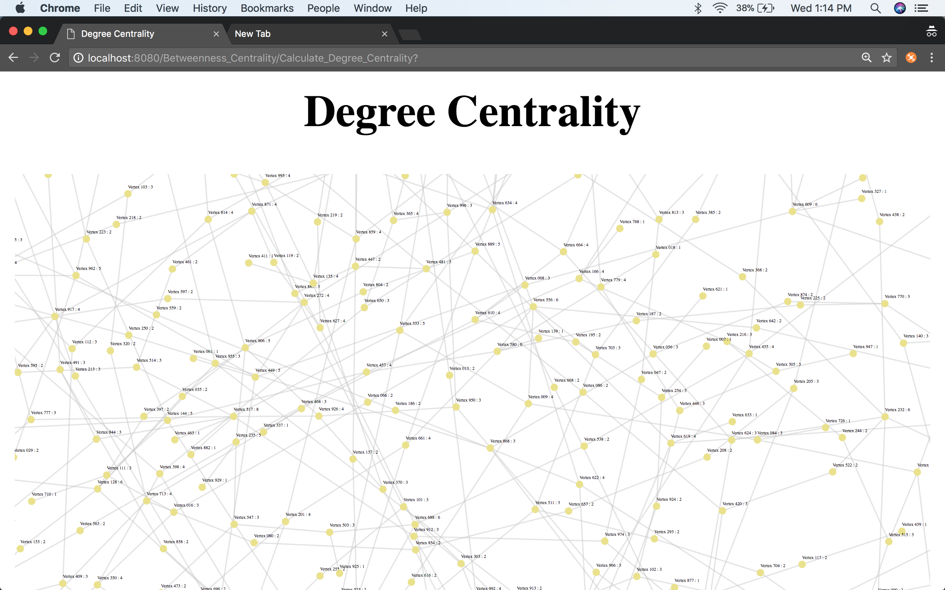

Fig-5

Closeness Centrality

* For 6 nodes and 7 edges

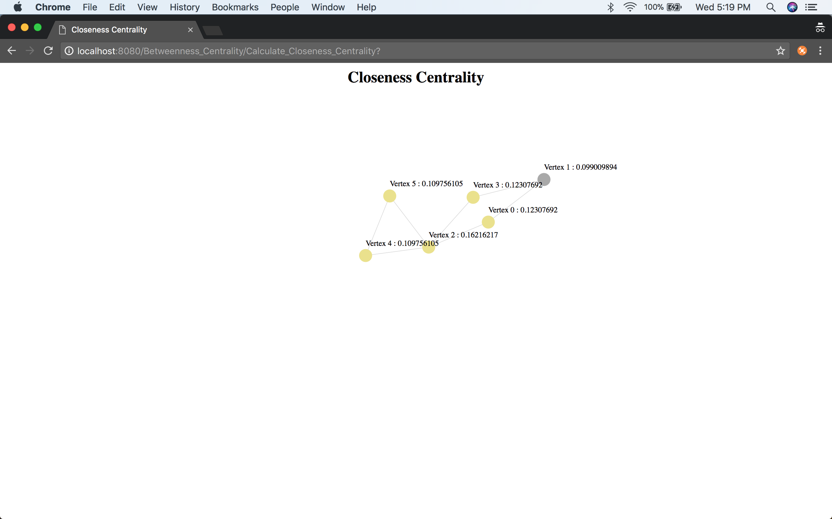

Fig-6

* For 880 nodes and 1000 edges

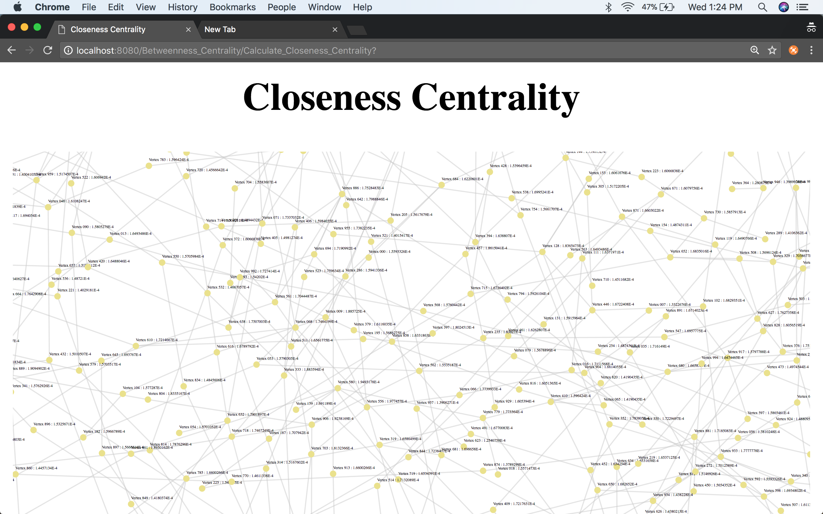

Fig – 7

Katz Centrality

* For 6 nodes and 7 edges

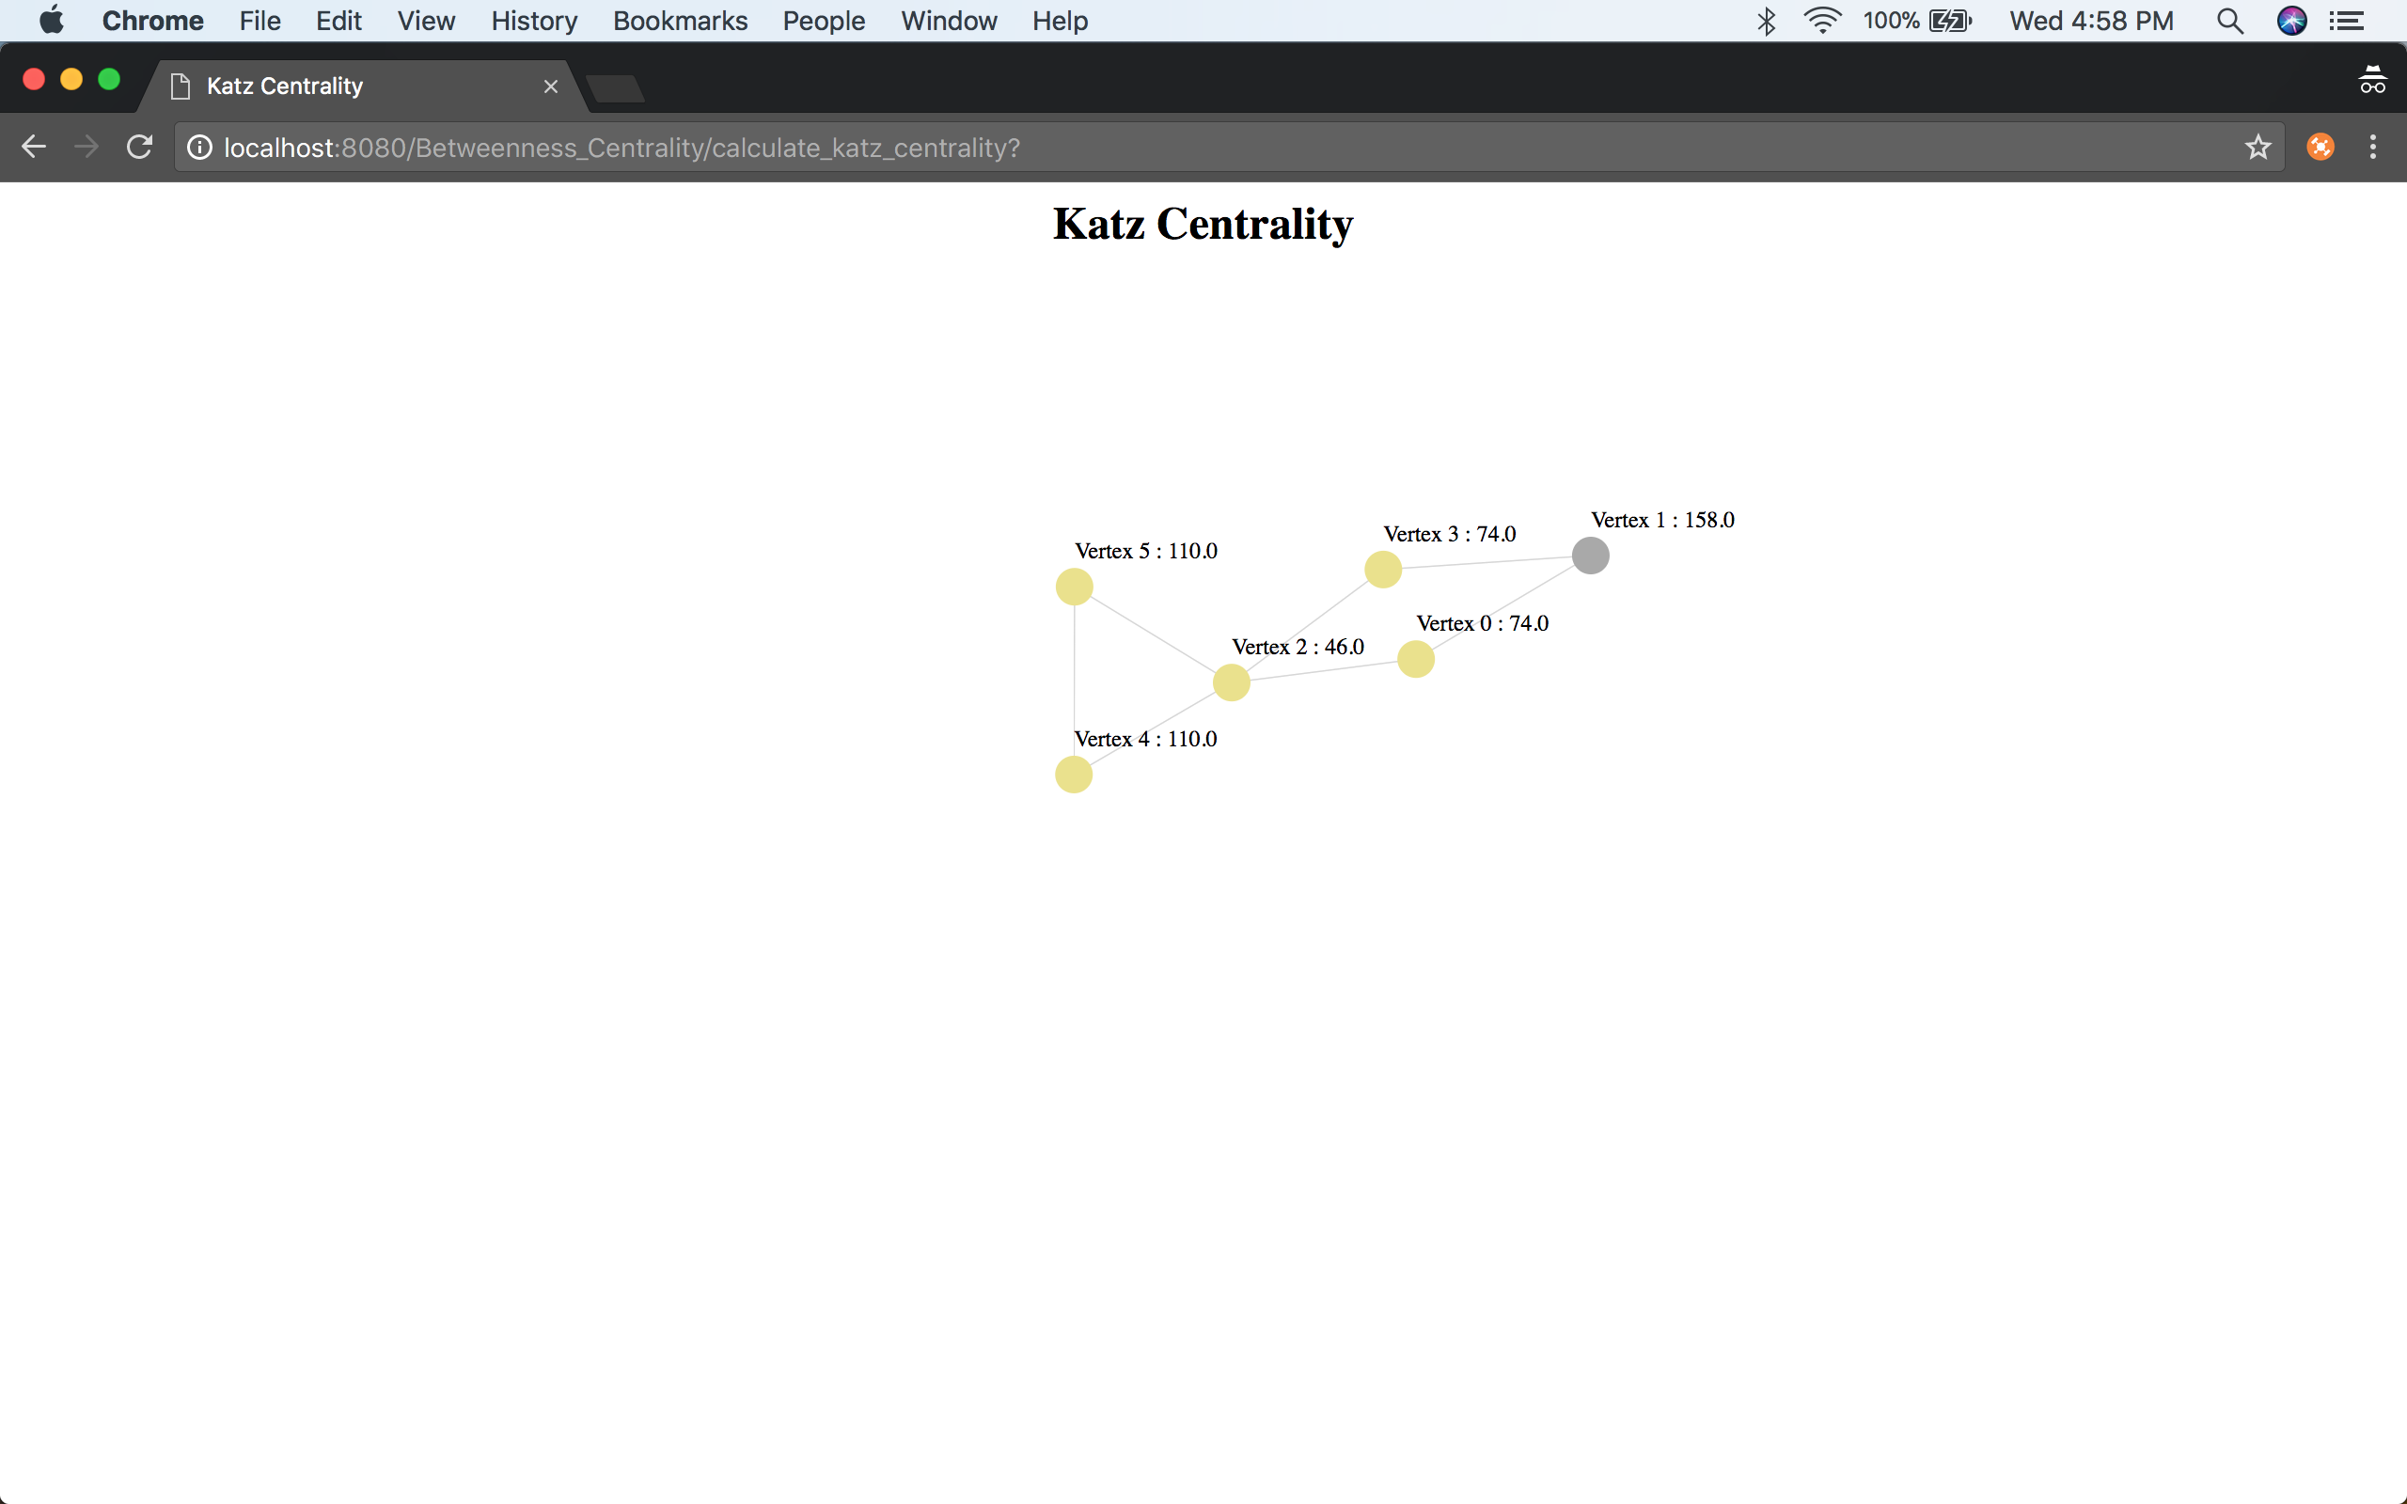

Fig-8

* For 880 nodes and 1000 edges

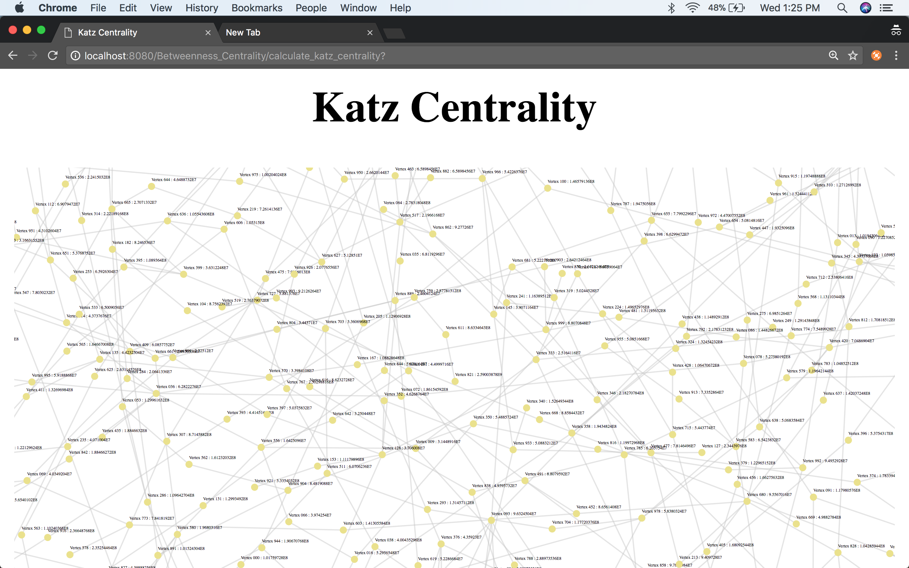

Fig-9

Final Centrality

* For 6 nodes and 7 edges

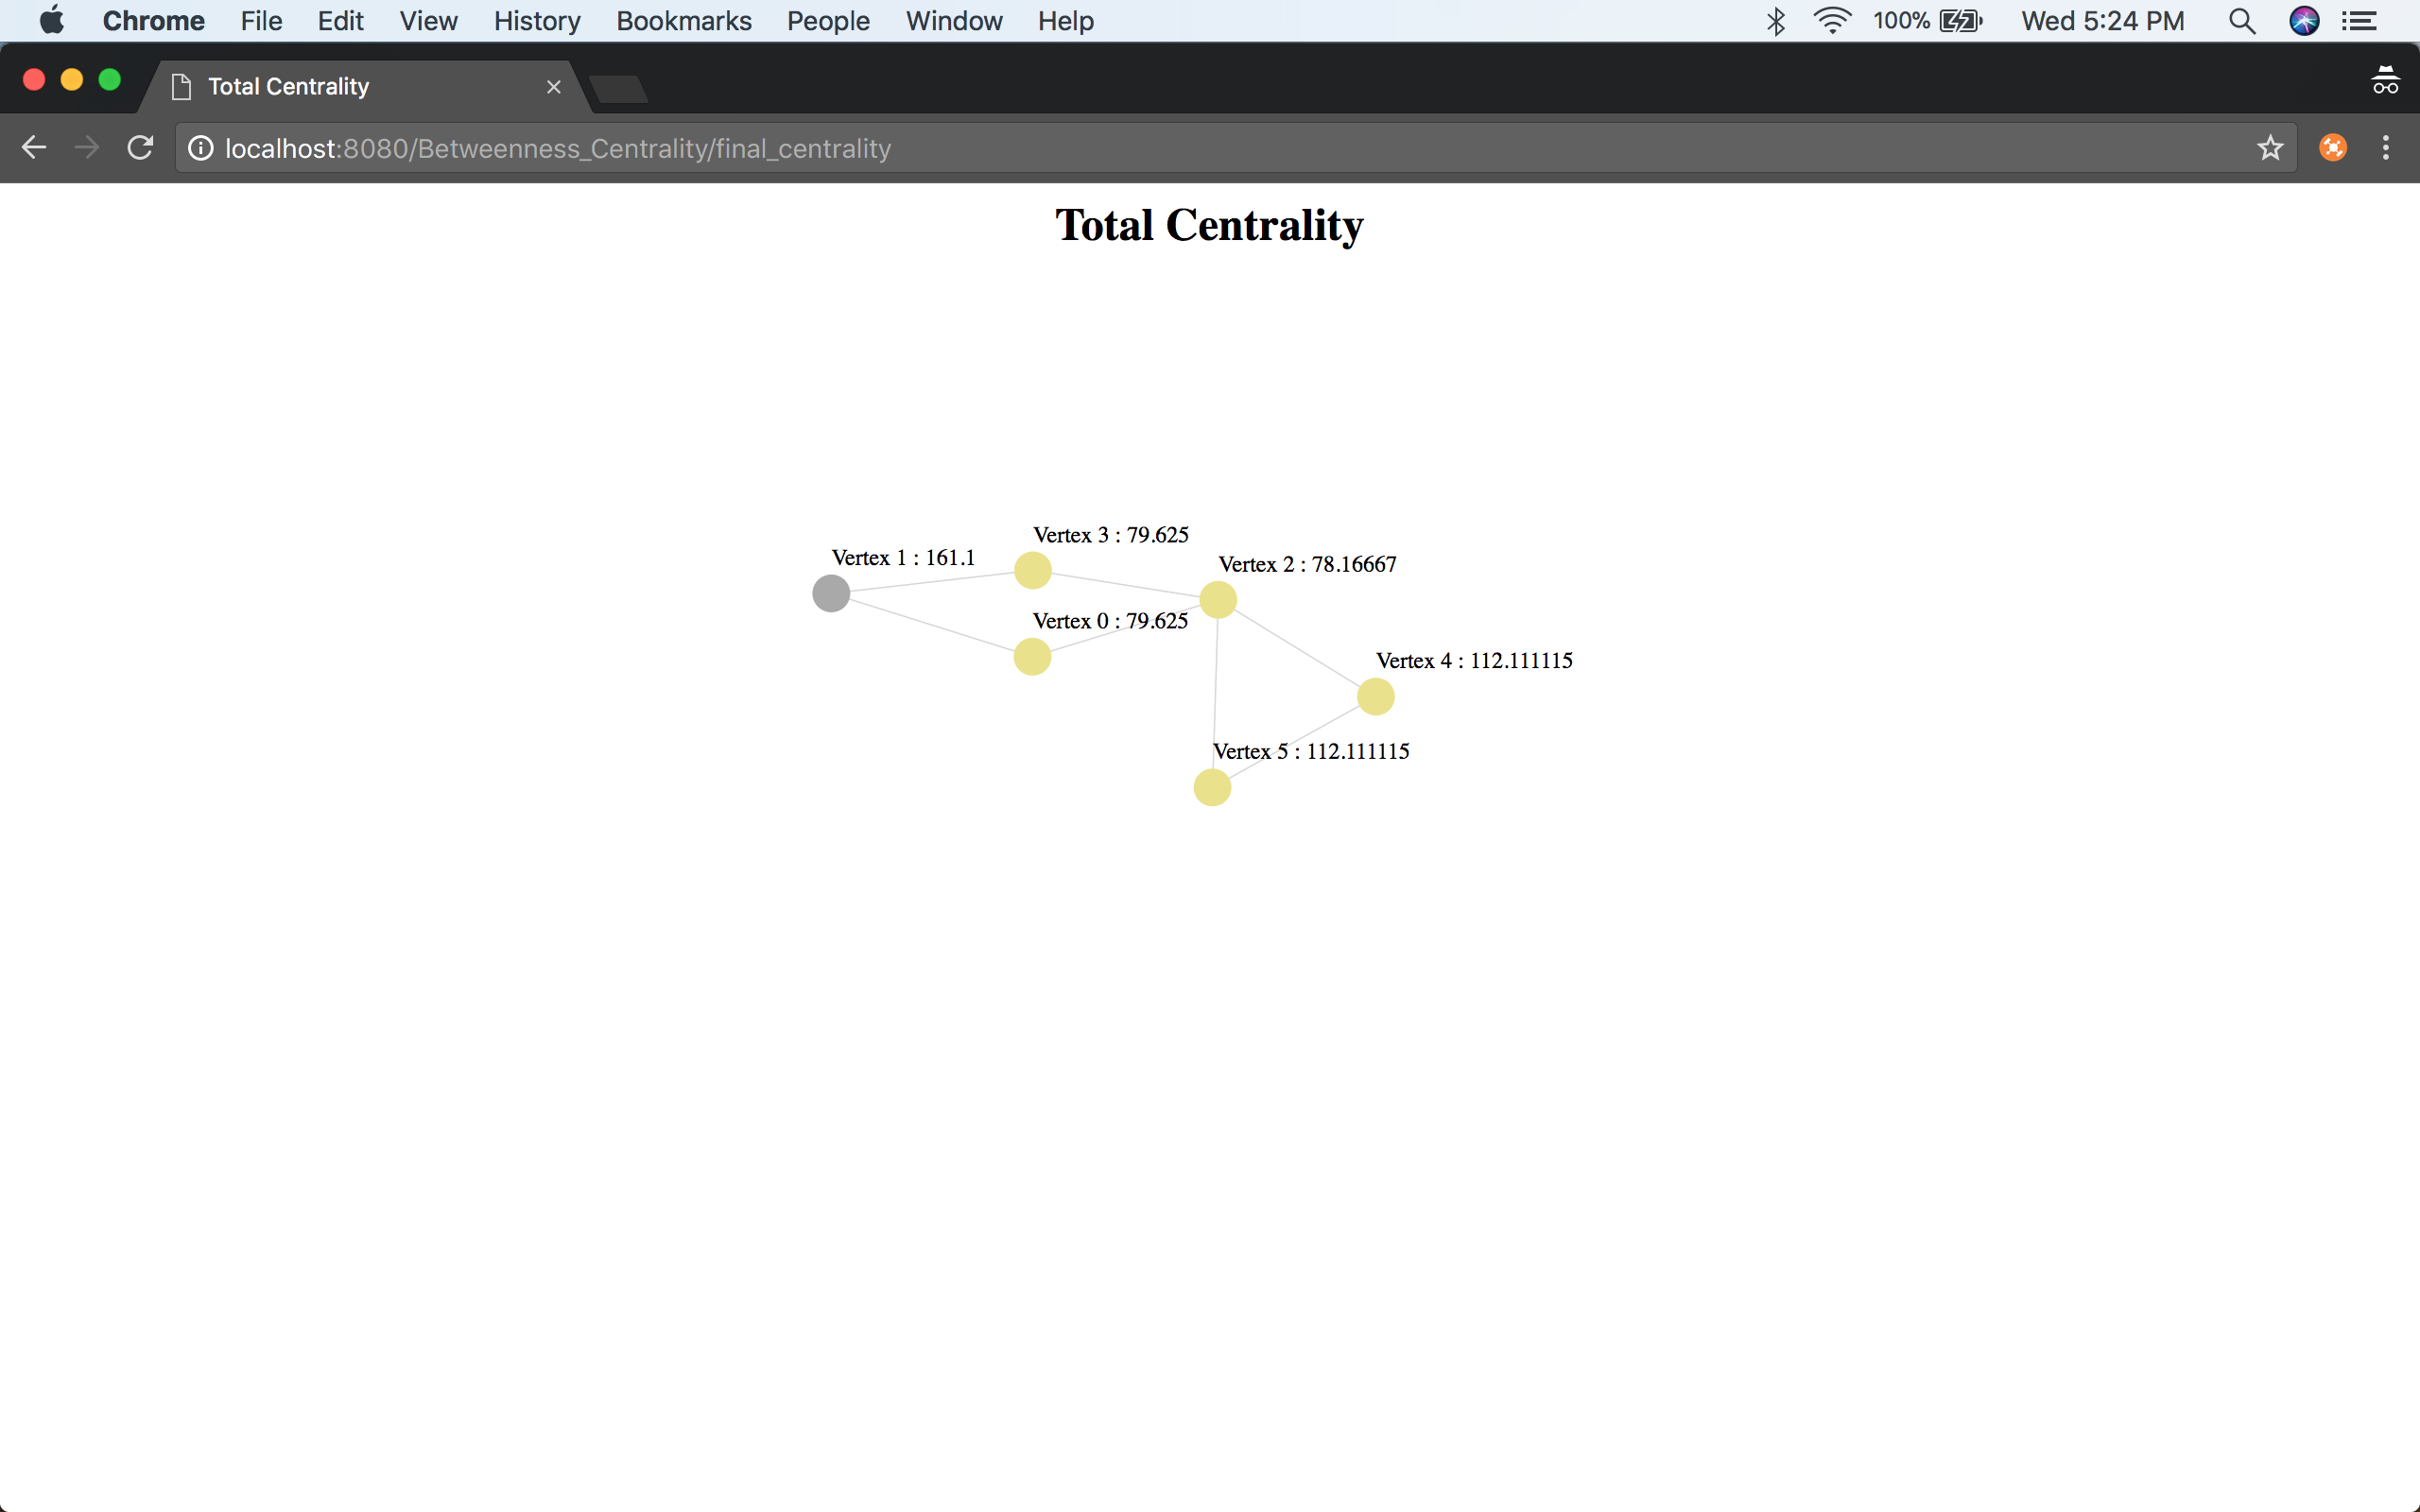

Fig-10

* For 880 nodes and 100 edges

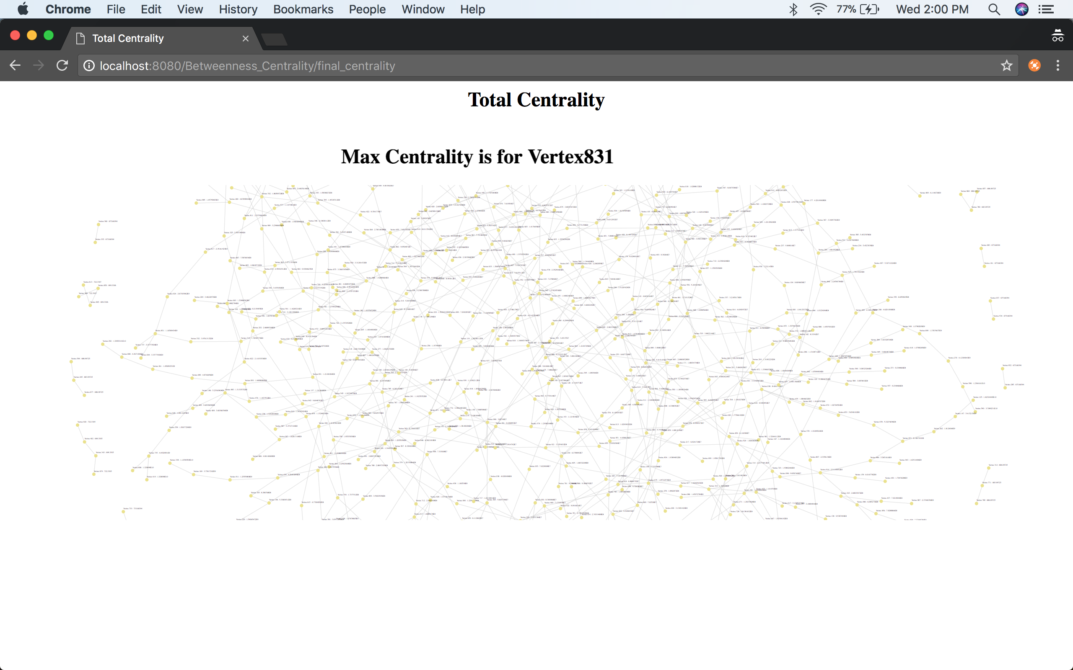

Fig-11

# SUMMARY AND DISCUSSION

* Centrality plays a vital role in graph analysis.
* Each centrality can be helpful only for a particular application. For example, Indegree of Degree Centrality can be helpful to gauge the most popular person whereas outdegree will be useful to gauge the gregariousness among group of people.
* Let’s analyze the final centrality after calculation of each centrality for the above set of examples:

1. Betweenness Centrality

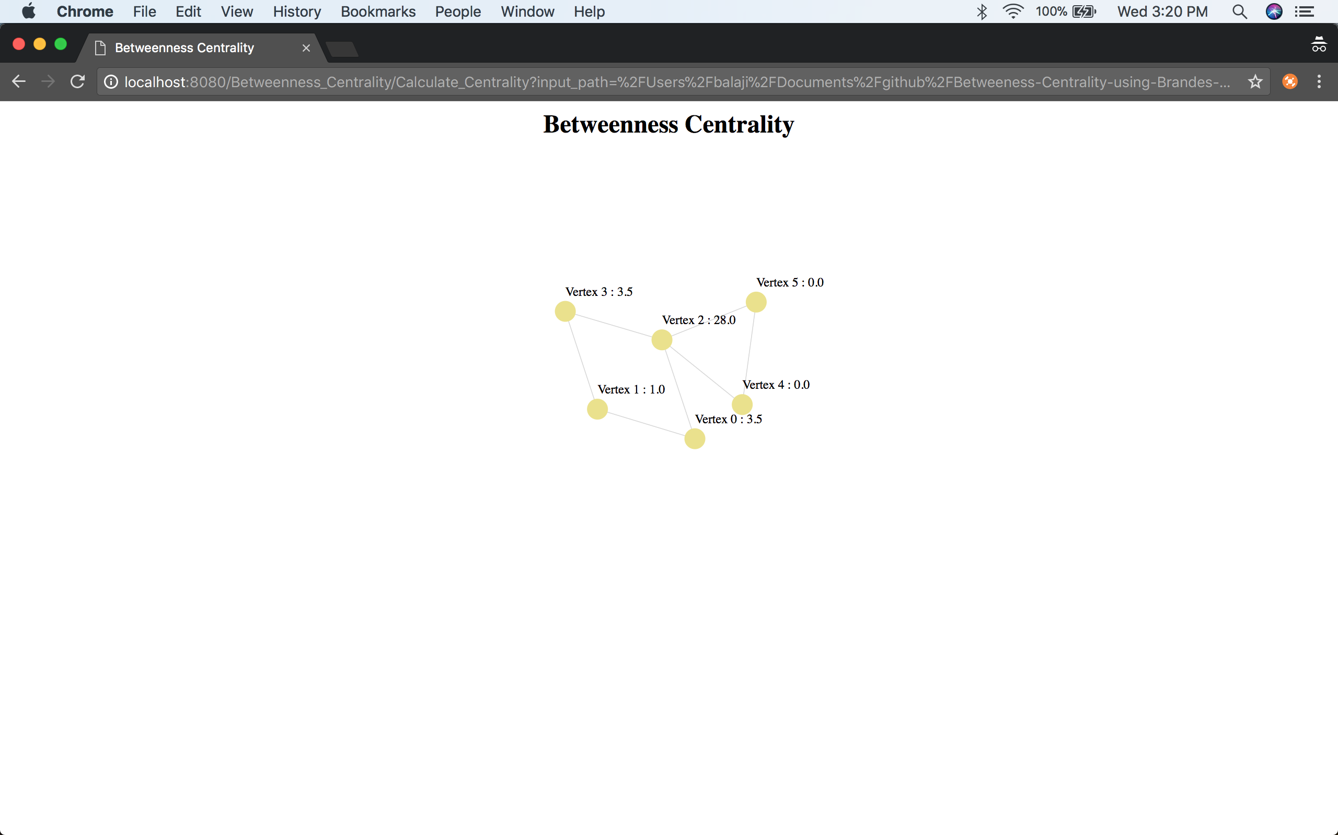

Fig-12

1. Degree Centrality

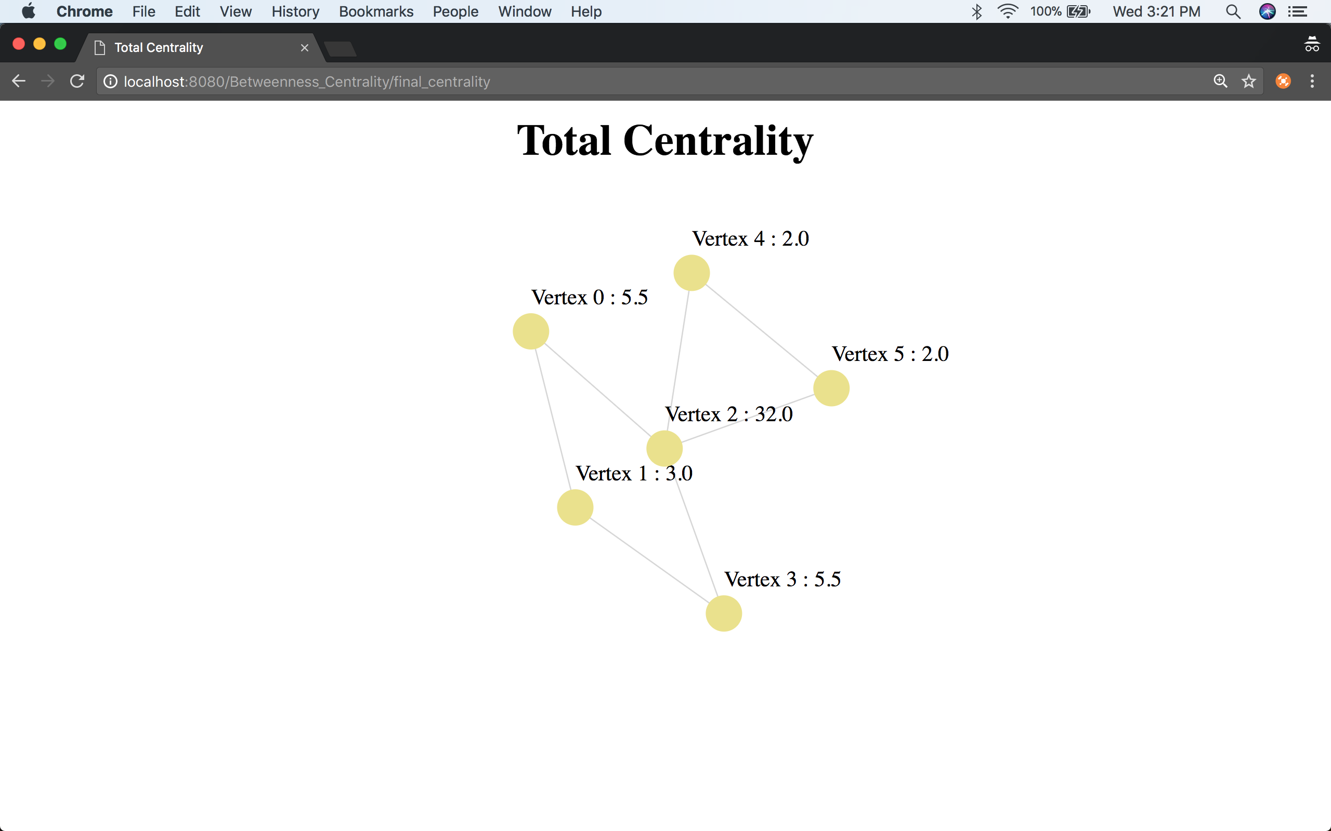

Fig-13

1. Closeness Centrality

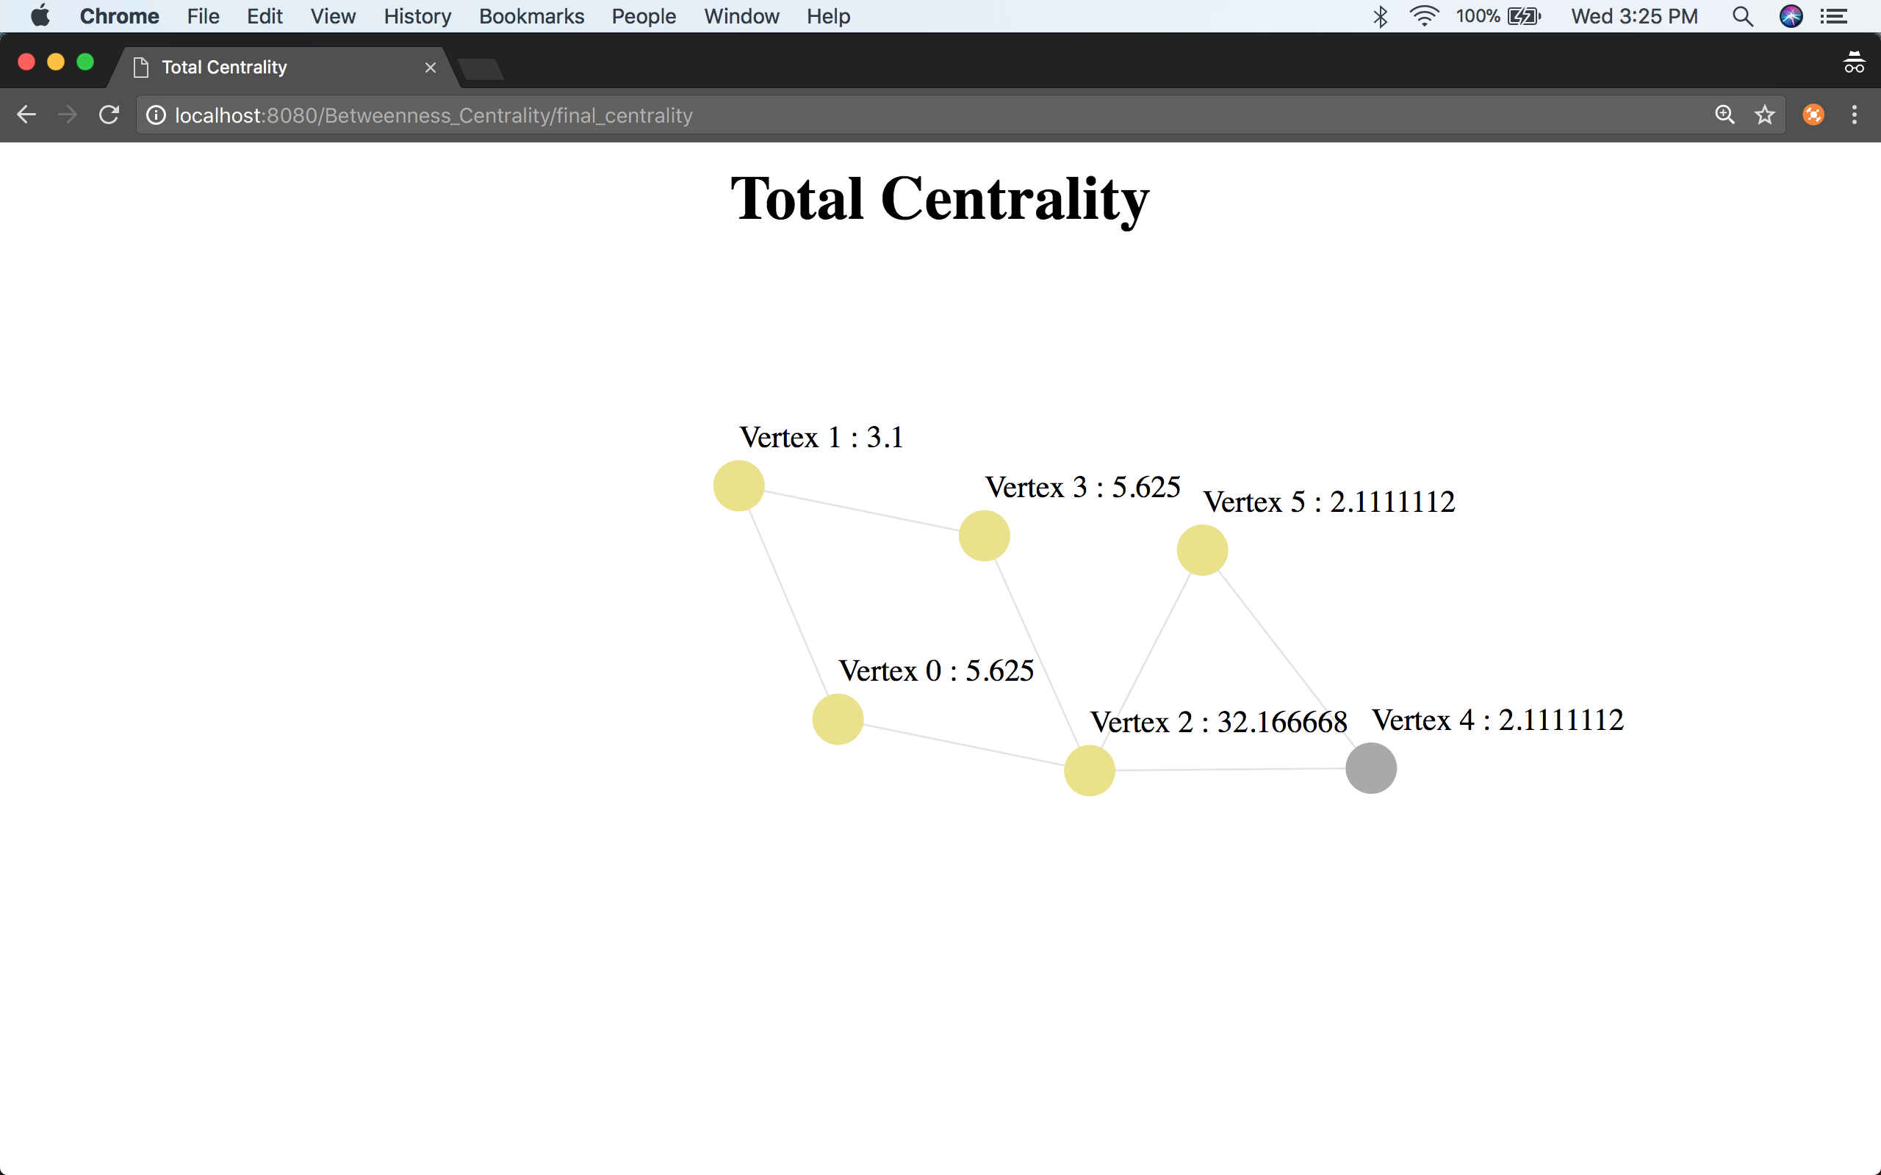

Fig-14

1. Katz Centrality

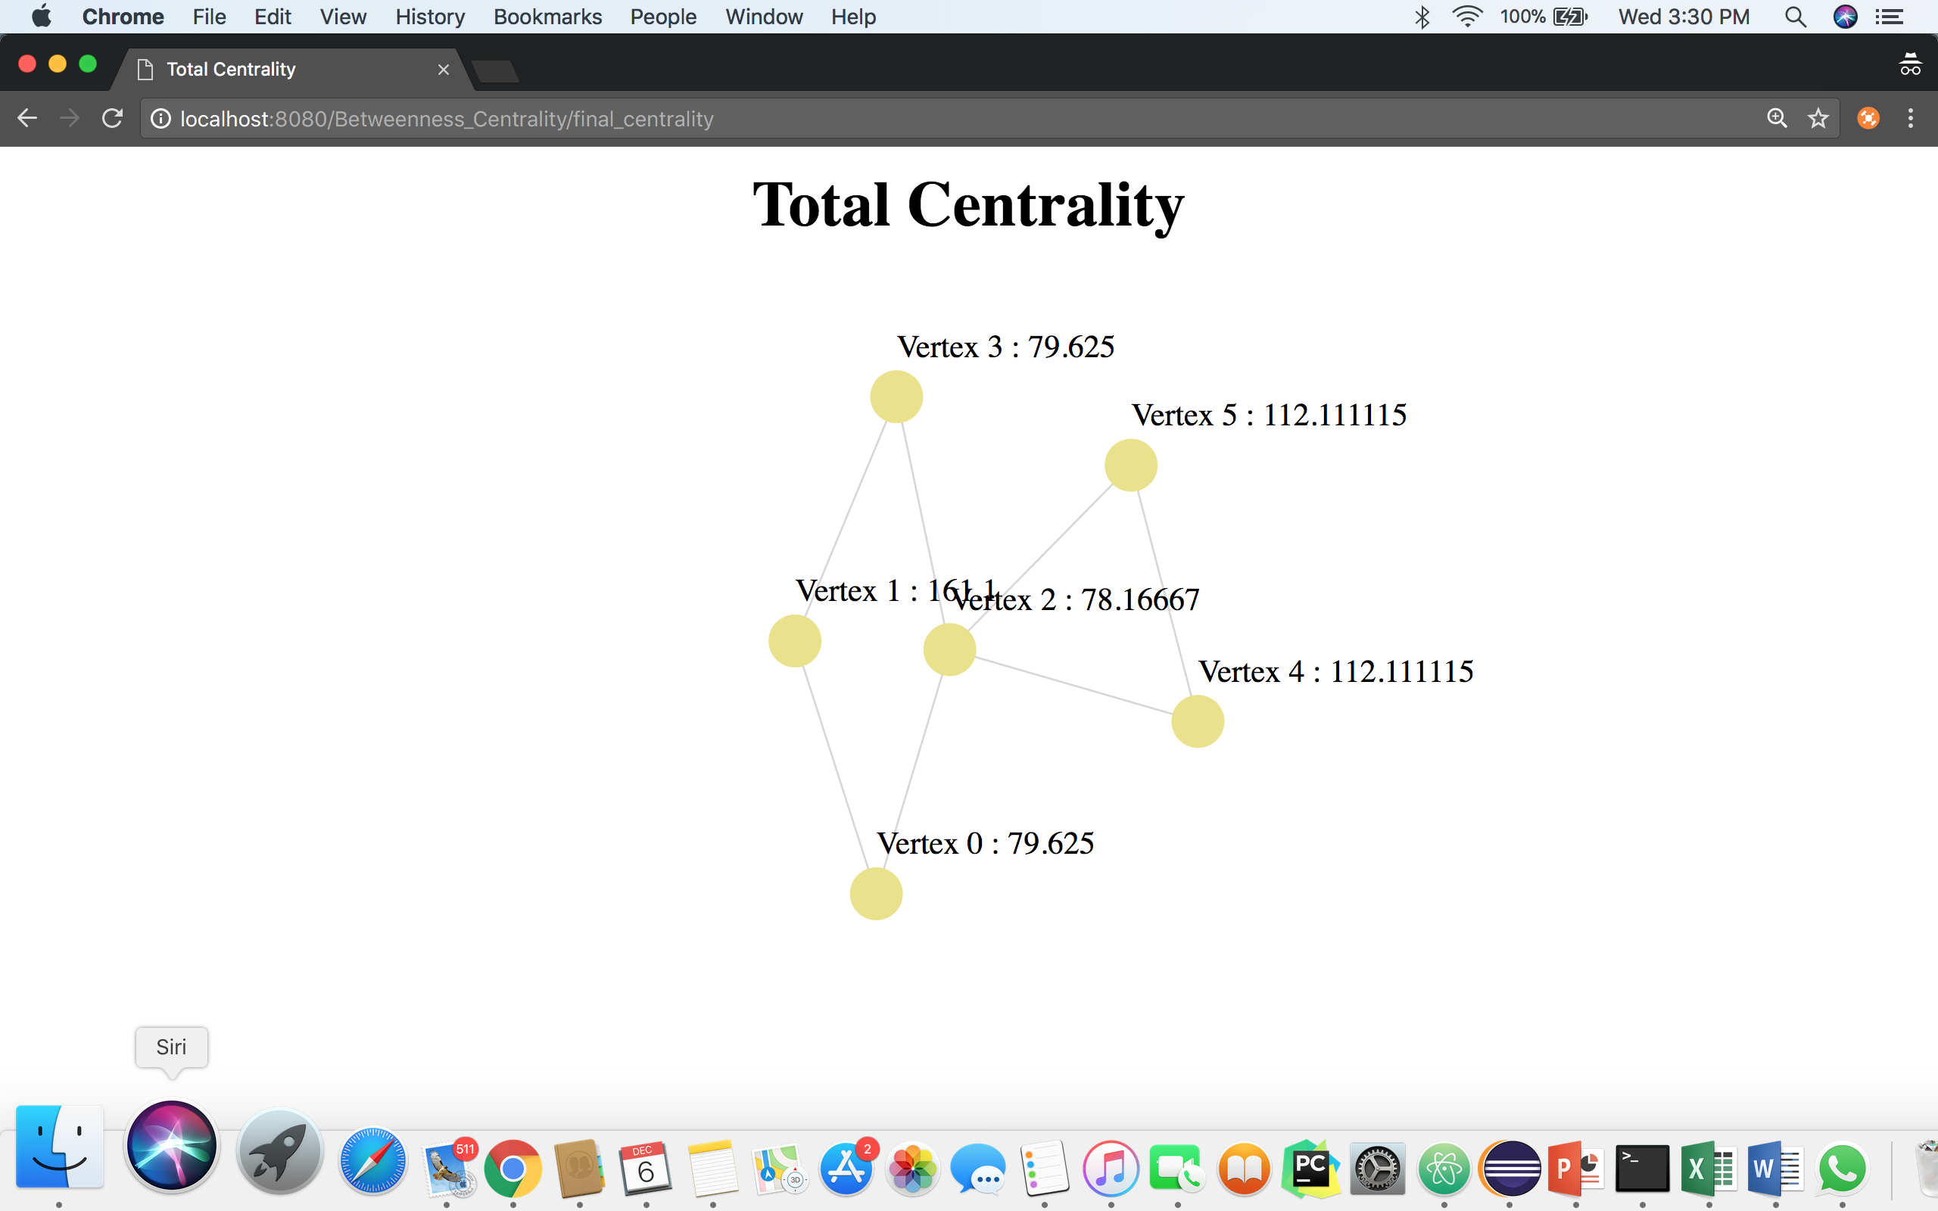

Fig-15

* The vertex 1 seems to have taken the lead after Katz Centrality by using attenuation factor of 3. The attenuation factor should be less than 1 to get the correct results.
* As a result, combined or the average scores of centralities cannot be considered for graph analysis.
* Time taken for calculation of centralities will be different for dense as well as sparse matrix. Also, the time will increase exponentially with the increase in the number of nodes and edges.
* So, the Brande’s algorithm has been used instead of Floyd-Warshall algorithm to calculate the Betweenness centrality. The disadvantage is that the algorithm can be used only for weightless edges. Also, negative cycles cannot be considered.
* The overall complexity for calculation of all the centralities is O (V2 log V + VE).

# REFERNCES

1. <https://en.wikipedia.org/wiki/Centrality>
2. <https://en.wikipedia.org/wiki/Closeness_centrality>
3. <https://en.wikipedia.org/wiki/Centrality#Degree_centrality>
4. <https://en.wikipedia.org/wiki/Betweenness_centrality>
5. <https://en.wikipedia.org/wiki/Katz_centrality>
6. <http://algo.uni-konstanz.de/publications/b-fabc-01.pdf>
7. *Fletcher, Jack McKay and Wennekers, Thomas (2017).*["From Structure to Activity: Using Centrality Measures to Predict Neuronal Activity"](http://www.worldscientific.com/doi/abs/10.1142/S0129065717500137)*. International Journal of Neural Systems. 0 (0): 1750013.*[doi](https://en.wikipedia.org/wiki/Digital_object_identifier)*:*[10.1142/S0129065717500137](https://doi.org/10.1142%2FS0129065717500137)*.*

# APENDIX

Code:

The code can be found at:

<https://github.com/ssgandham/Calculate-Betweeness-Centrality-using-Brandes-Algorithm-Closeness-Centrality-and-Degree-Centrality>

Video:

The video can be seen at:

<https://www.youtube.com/watch?v=1IeoV8dlbNE&feature=youtu.be>